**EXP 9)** Create a simple cloud software application for Hospital information system for SIMATS Hospital using any Cloud Service Provider to demonstrate SaaS with fields of patient name, age, address, phone, email, Attender name, attender phone, doctor name, diseases, etc

**PROCEDURE:**

**STEP 1:** GOTO ZOHO.COM

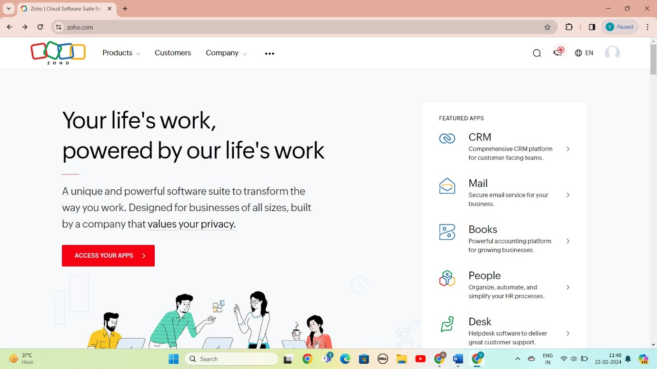

STEP 2: LOGIN TO THE ZOHO.COM

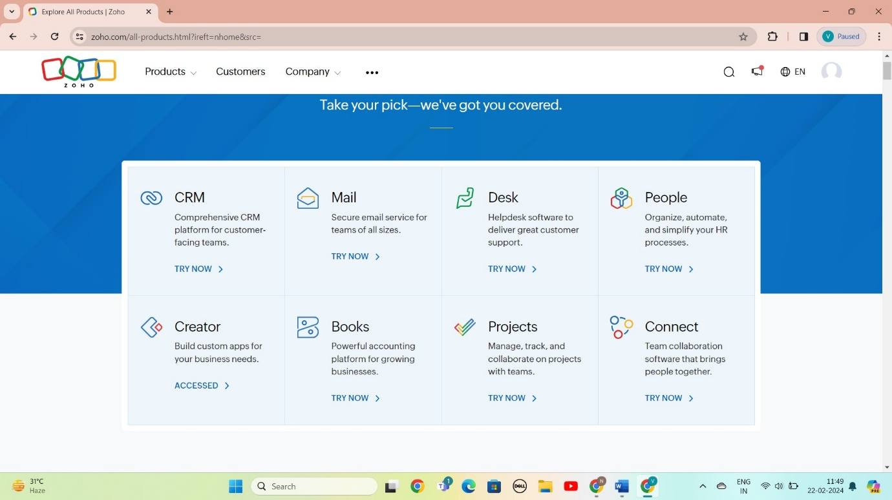

STEP 3: SELECT A CREATE FROM SCRATCH

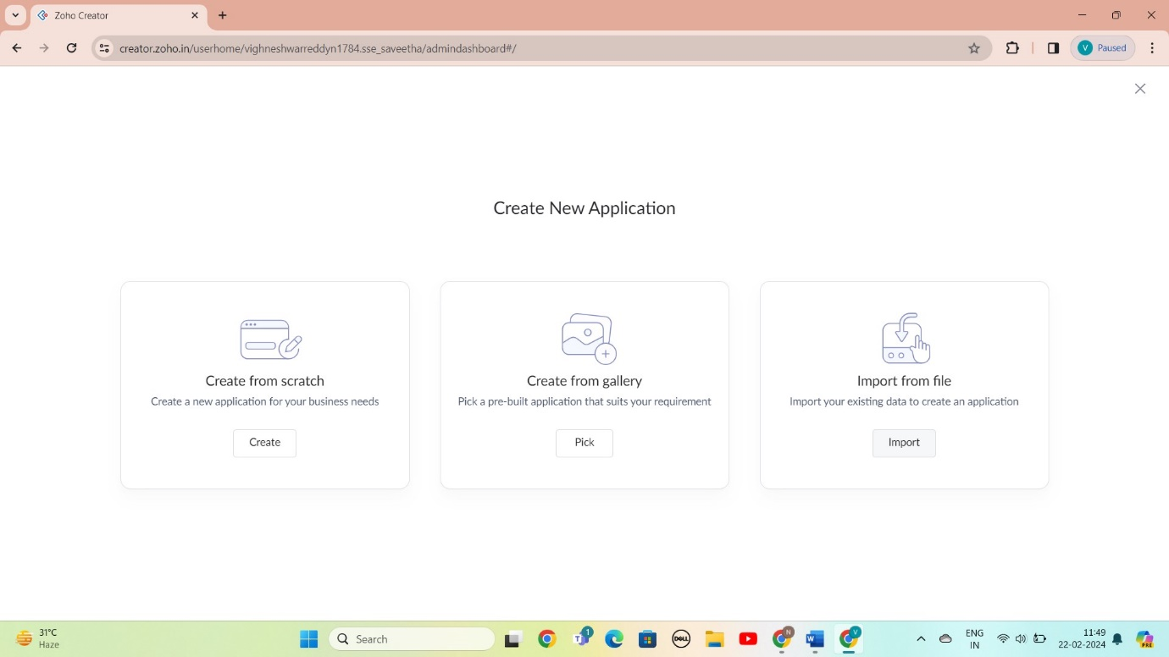

STEP 4: SELECT APPLICATION NAME AS Hospital information system

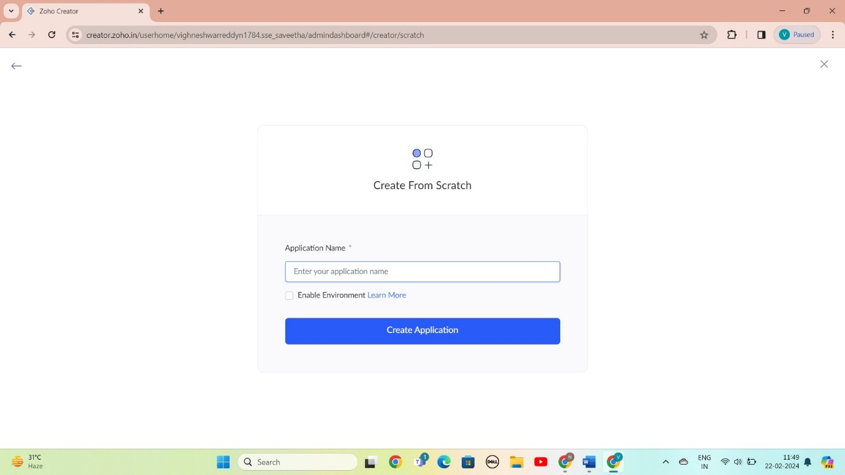

STEP 5: CREATED NEW FORM

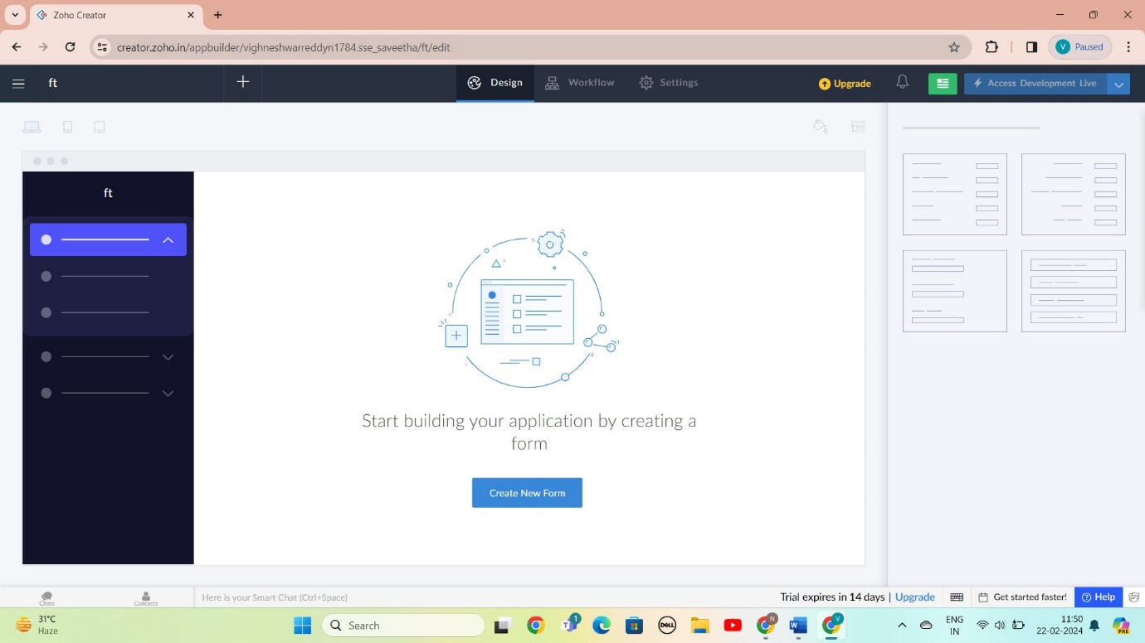

STEP 6: SELECT BASIC FILED FROM GIVEN BELOW AND DEVELOP APPLICATION

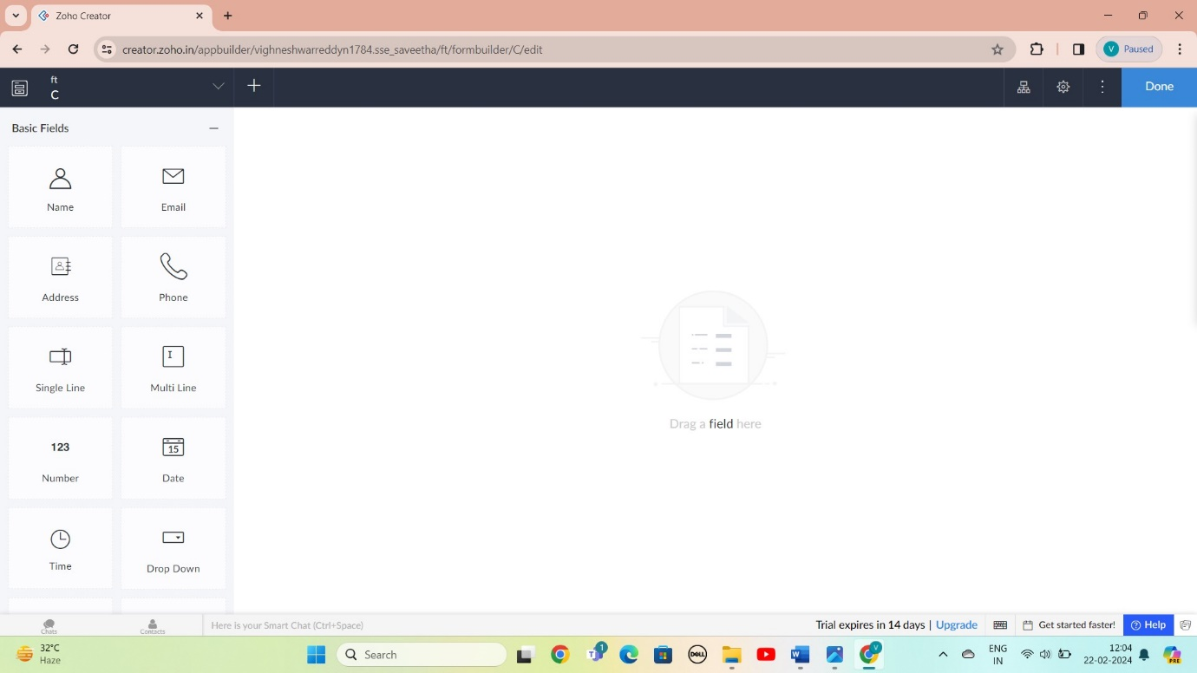

STEP 7: THE SOFTWARE AS BEEN CREATE SLOT BOOKING TO HEAITH CHECK UP

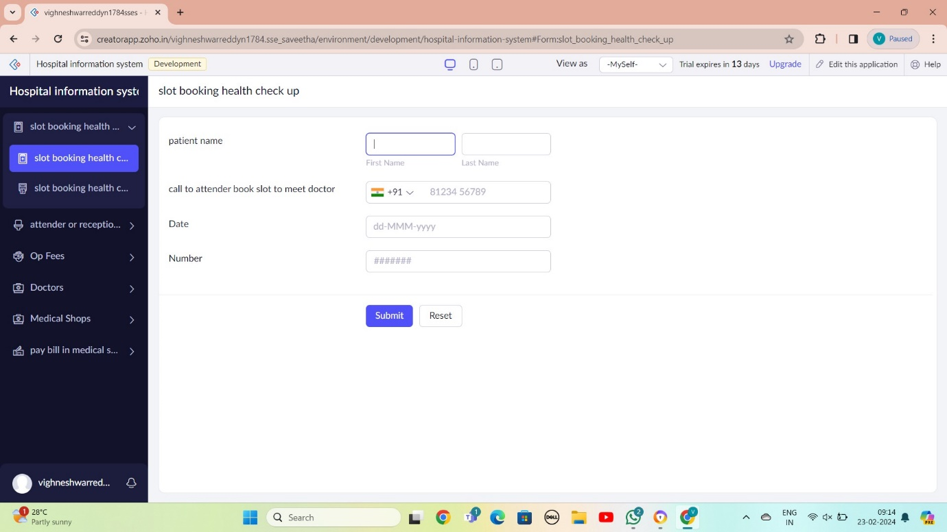

STEP 8: THE SOFTWARE AS BEEN CREATE RESPTIONIST

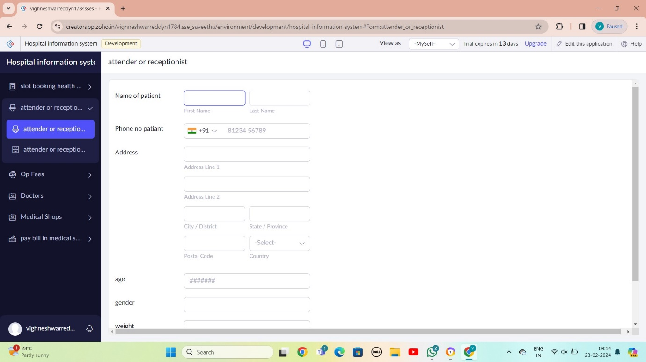

STEP 9: THE SOFTWARE AS BEEN CREATE OP FEE

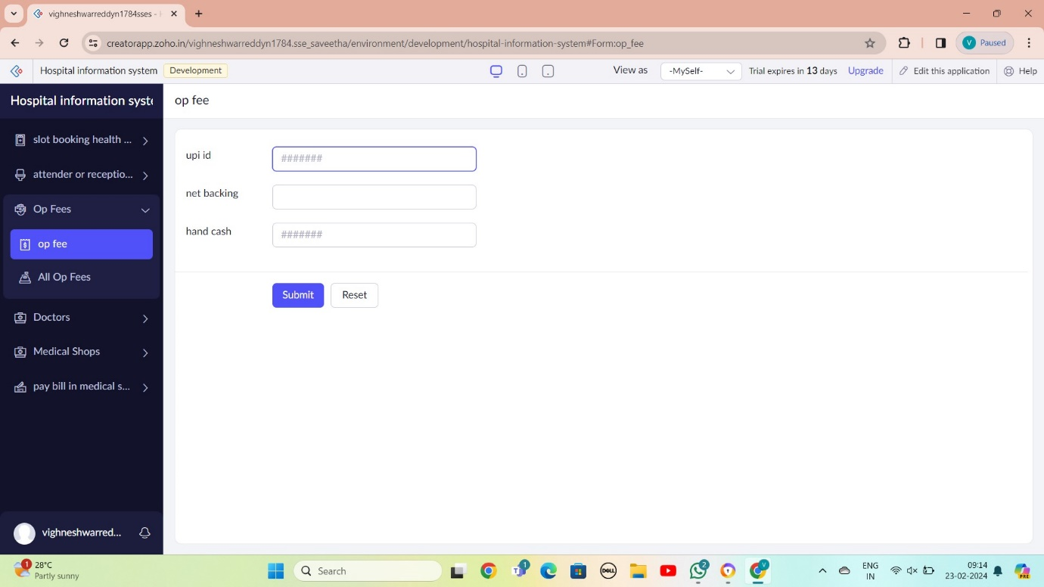

STEP 10: THE SOFTWARE AS BEEN CREATE DOCTOR COUNSCLING

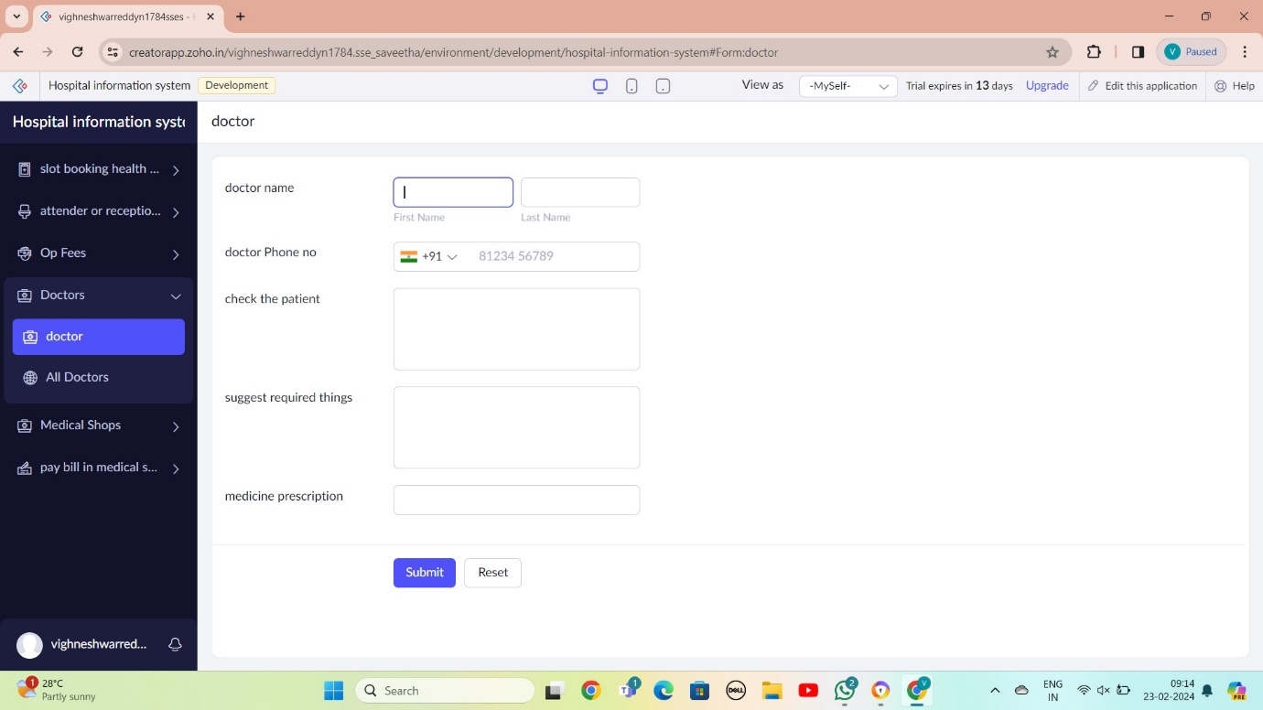

STEP 11: THE SOFTWARE AS BEEN MEDICAL SHOP

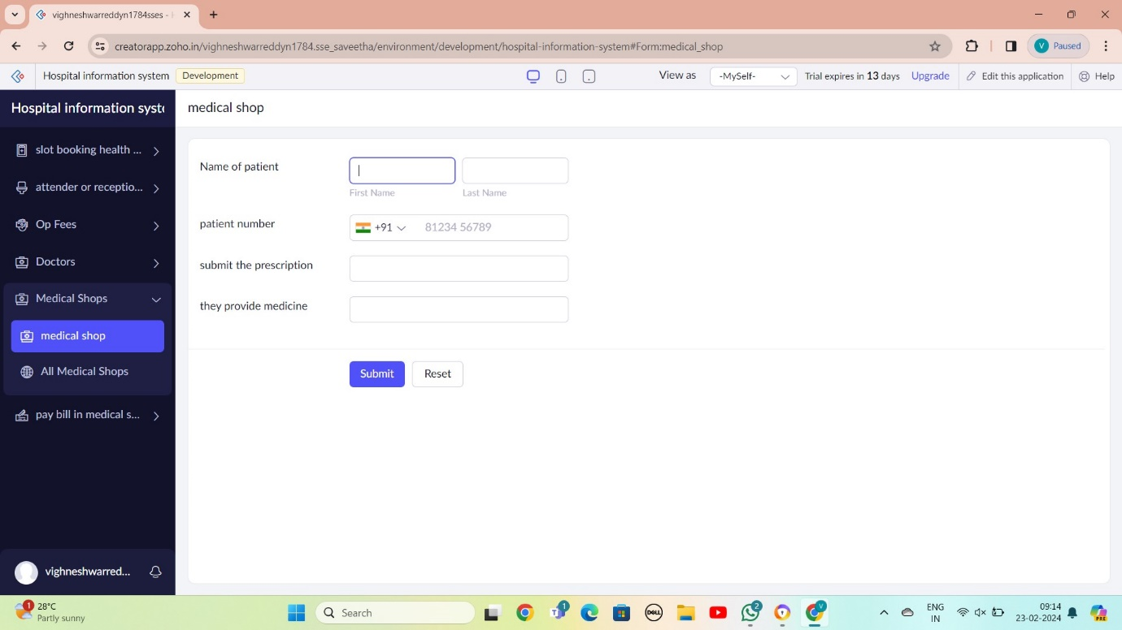

STEP 12: THE SOFTWARE AS BEEN CREATE

